**Bangladesh University of Business & Technology**

**BUBT**



**Project On:**

**GPA & CGPA Calculation**

**Department of Computer Science And Engineering**

Date of Submission :

**GPA & CGPA CALCULATION PROJECT**

A project

submitted to the department of Computer Science and Engineering in partial fulfillment of the requirements for the degree of

**Bachelor of Science in Computer Science and Engineering**

**By**

**Md Sahrial Alam (ID: 17182103334)**

[**Md Iqbal Hasan**](https://www.facebook.com/) **(ID: 17182103317)**

[**Md. Aminul**](https://www.facebook.com/mdaminulislam.bulbul.50) **Islam (ID: 17182103319)**

**Supervised by**

**Md Mamun Hossain**

**Lecturer**

Department of Computer Science and Engineering (CSE)

Bangladesh University of Business and Technology (BUBT)

Mirpur-2, Dhaka-1216, Bangladesh.

**ABSTRACT**

**GPA & CGPA CALCULATION PROJECT**

Our project is based on calculate GPA & CGPA. The most of the students face a problem to calculate their marks by GPA & CGPA. In our project we will give the following details:

* Course & semester information (credit & point)
* How to calculate GPA?
* How to calculate CGPA?

The given project “GPA &CGPA CALCULATION” is very helpful to for calculation marks into point with grade. This is very useful for university students like ours.

**DECLARATION**

We declare that this thesis and the work presented in it are our own and has been generated by uses the result of our own original research

We confirm that:

* This Work is done wholly or mainly while in candidature for a research degree at this University.
* This project work has not been previously submitted for any degree at this

university or any other educational institutes.

* We have quoted from the work of others. the source is always given. With the exception of such quotations, this thesis is entire our own work.

**------------------ ------------------------ -----------------**

**Md Sahrial Alam** [**Md Iqbal Hasan**](https://www.facebook.com/)[**Md. Aminul**](https://www.facebook.com/mdaminulislam.bulbul.50) **Islam**

**(ID: 17182103334) (ID: 17182103317) (ID: 17182103319)**

**CERTIFICATE**

This is to certify that **Md Sahrial Alam ,** [**Md Iqbal Hasan**](https://www.facebook.com/) **and** [**Md Aminul**](https://www.facebook.com/mdaminulislam.bulbul.50) Islam are students of B.Sc. in CSE have completed their project work titled “GPA & CGPA Calculation” satisfactorily in partial fulfillment for the requirement of B.Sc.in CSE. Bangladesh University of Business and Technology in the year 2019.

**------------------ ------------------------ -----------------**

**Md Sahrial Alam** [**Md Iqbal Hasan**](https://www.facebook.com/)[**Md Aminul**](https://www.facebook.com/mdaminulislam.bulbul.50) **Islam**

**(ID: 17182103334) (ID: 17182103317) (ID: 17182103319)**

------------------------

**Project Supervisor**

**(Md Mamun Hossain)**

**Lecturer**

Department of Computer Science and Engineering (CSE)

Bangladesh University of Business and Technology (BUBT)

**DEDICATION**

Dedicated to our parents for all their love and inspiration.

j0230876

**ACKNOWLEDGEMENTS**

First of all, we are thankful and expressing our gratefulness to Almighty Allah who offers us His divine blessing, patient, mental and physical strength to complete this project work.

We are deeply indebted to our project supervisor Md Mamun Hossain, lecturer of

Department of Computer Science and Engineering (CSE), Bangladesh University of Business and Technology (BUBT). His scholarly guidance, important suggestions, work for going through our drafts and correcting them, and generating courage from the beginning to the end of the project work has made the completion of this project possible.

We would like to express our deep gratitude to our Teacher Arunavo dey, Assistant Professor, Department of Computer Science and Engineering (CSE), Bangladesh University of Business and Technology (BUBT). It was fantastic to get help from him and without his support it will be tough for us to reach the accurate goal.

A very special gratitude goes out to all our friends for their support and help to implement our works. The discussions with them on various topics of our works have been very helpful for us to enrich our knowledge and conception regarding the work.

Last but not the least; we are highly grateful to our parents and family members for supporting us spiritually throughout writing this thesis and our life in general.

**APPROVAL**

This project “GPA and CGPA Calculation” Submitted by Md Sahrial Alam, Md Iqbal Hasan, Md Aminul ID NO: 17182103334, 17182103317 and 17182103319 Department of Computer Science and Engineering (CSE), Bangladesh University of Business and Technology (BUBT) under the supervision of Md Mamun Hossain, Lecturer, Department of Computer Science and Engineering has been accepted as satisfactory for the partial fulfillment of the requirement for the degree of Bachelor of Science (B.Sc. Eng.) in Computer Science and Engineering and approved as to its style and contents.

-----------------------------

**Supervisor:**

**Md Mamun Hossain**

Lecturer

Department of Computer Science and Engineering (CSE)

Bangladesh University of Business and Technology (BUBT)

Mirpur-2, Dhaka-1216, Bangladesh.

**------------------------**

**Chairman:**

**Prof. M. Ameer Ali**

Professor and Chairman

Department of Computer Science and Engineering (CSE)

Bangladesh University of Business and Technology (BUBT)

Mirpur-2, Dhaka-1216, Bangladesh.

© Copyright by Md Sahrial Alam (17182103334), Iqbal Hasan (17182103317), and Md. Aminul Islam (17182103319)

All Right Reserved

**ABBREVIATIONS**

**Synonyms and Acronyms Descriptions**

EMP Employee Management Project

RAMRandon Access Memmory

**TABLE OF CONTENTS**

**1.Introduction**

1.1 Introduction and Objective

1.2 Project Scope

1.3 Deliverables

1.4 why we use c programming

**2. software and hardware specification**

**3. About Grading system**

**4. project core description**

**5. Output**

**6.System development environment**

**7.CONCLUSION**

1.INTRODUCTION

* 1. **INTRODUCTION & OBJECTIVE**

The full form of **CGPA** is Cumulative Grade Point Average.

_ To **calculate** your grade point average, first multiply the number of credits each class is worth by the point value for the letter grade that you earned in that class. Next, total the grade points of **all** of your classes for that **semester** and divide it by the number of credit hours that you attempted.

**1.2**. **Project Scope**:

The scope of the project is to calculate CGPA easily and it is efficient for student. Whom want to calculate his CGPA just input his number then this program automatically calculates his CGPA or GPA and show him.

**1.3 Project Deliverables**

_ We can store the employee’s personal details for internal accessibility.

_ We can post the program details on intranet and we can also prepare the program timetable.

**Why we use C:**

C was initially used for system development work, particularly the programs that make-up the operating system. C was adopted as a system development language because it produces code that runs nearly as fast as the code written in assembly language. Some examples of the use of C:

– Operating Systems

– Language Compilers

– Assemblers

– Text Editors

– Print Spoolers

– Network Drivers

– Modern Programs

– Databases

– Language Interpreters

– Utilities

**2.SOFTWARE AND HARDWARE SPECIFICATIONS**

**HARDWARE SPECIFICATION –MINIMUM REQUIREMENTS**

_ Pentium III processor

_ 128 MB Ram

_ Hard disk 40 GB

_ Microsoft Compatible 101 or more Key Board

**SOFTWARE SPECIFICATION**

_ JDK 1.5 Enterprise Edition (J2EE)

_ Apache Tomcat

_ NET Beans 7.1.2

_ JDBC/ODBC drivers installed.

_ Functional Java enabled browser.

_ Data Base (Oracle 10g ).

_ Operating System (Windows).

**3. About Grading system:**

|  |  |  |  |
| --- | --- | --- | --- |
| **Numerical Grade** | **Letter Grade** | | **Grade point** |
| 80% and above | A+ | A Plus | 4.00 |
| 75 % to less than 80 % | A | A Regular | 3.75 |
| 70 % to less than 75 % | A- | A Minus | 3.50 |
| 65 % to less than 70 % | B+ | B Plus | 3.25 |
| 60 % to less than 65 % | B | B Regular | 3.00 |
| 55 % to less than 60 % | B- | B Minus | 2.75 |
| 50 % to less than 55 % | C+ | C Plus | 2.50 |
| 45 % to less than 50 % | C | C Regular | 2.25 |
| 40 % to less than 45 % | D |  | 2.00 |
| less than 40 % | F |  | 0.00 |

**4.Project core description:**

**Computation of Grade Point Average(GPA):**

**Grade Point averag(GPA)** = ∑ G x C / ∑ G

G = Grade point C = Credit hour

Suppose a student has complete 4 courses in a semester and obtained the following grade:

|  |  |  |  |  |
| --- | --- | --- | --- | --- |
| Course | Grade earned | Grade point(G) | Credit hour(C) | G x C |
| CSE 121 | A | 3.75 | 3 | 11.25 |
| CSE 122 | A | 3.75 | 1.5 | 5.625 |
| MAT 121 | B+ | 3.25 | 3 | 9.75 |
| CSE 103 | A+ | 4 | 3 | 12 |
|  |  |  | Total= 10.5 | 38.625 |

GPA= ∑ G x C / ∑ C = 38.625 / 10.5 = 3.67 That is GPA = A-

First of all we use many feature of c programming language like Array, conditional statement, switch case , mathematical operation and so on to complete this project. At first when user run this program they can chose one from four option that we include in this project using switch case.

1 for GPA calculate

1. for CGPA calculate
2. for Method that we use
3. for Exit.

When user press 1 then program go to cgpa calculate function. Then another choosing option for user which semester gpa he/she want to calculate . after input the number of semester program automatically show those semester subject and credit. After that user can input his achieved number of those subject and then he will see his GPA within a second.

Like this other function will be called when user press 2,3 or 4 and then those function do their job and will show then result. Below I have given some sample output………….

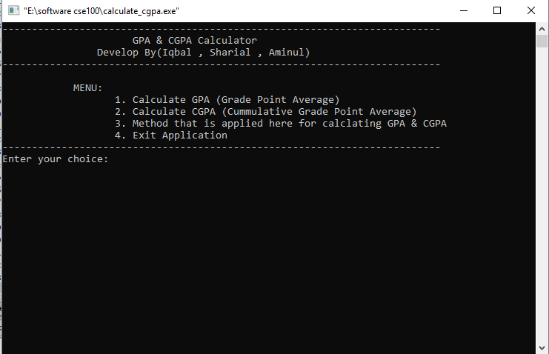

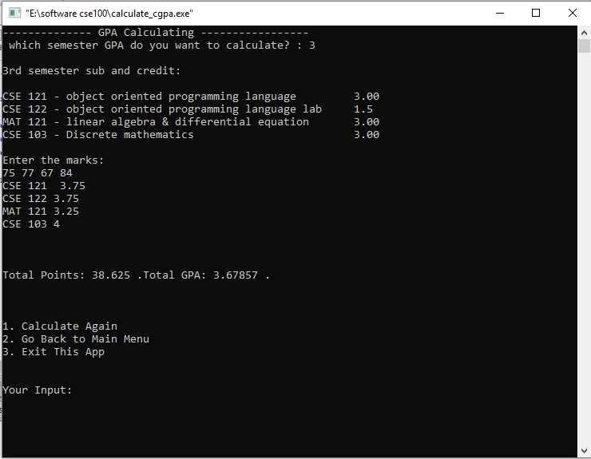

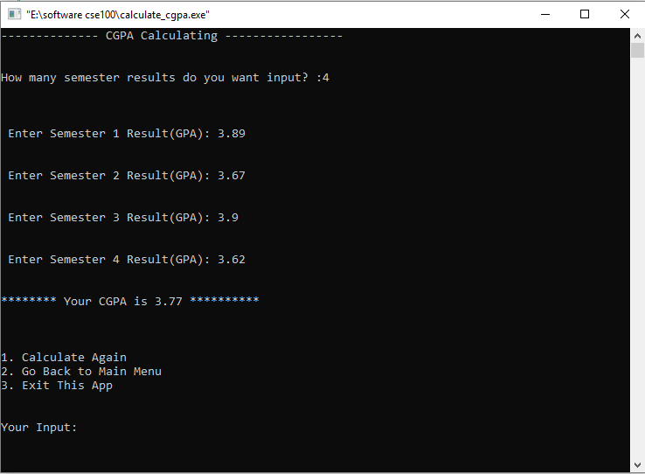

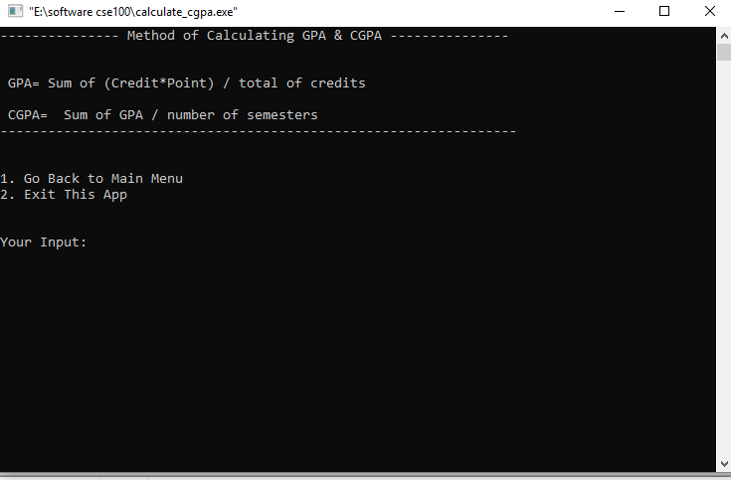

**6.SYSTEM DEVELOPMENT ENVIRONMENT**

**6.1 About c**

C is a general-purpose, high-level language that was originally developed by Dennis M. Ritchie to develop the UNIX operating system at Bell Labs. C was originally first implemented on the DEC PDP-11 computer in 1972.

The UNIX [operating system](https://en.wikipedia.org/wiki/Operating_system), the C compiler, and essentially all [UNIX](https://tekslate.com/tutorials/unixlinux/) application programs have been written in C. [C](https://tekslate.com/history-c-language/) has now become a widely used professional language for various reasons:

– Easy to learn

– Structured language

– It produces efficient programs

– It can handle low-level activities

– It can be compiled on a variety of computer platform

**7.PROJECT TESTING**

**7.1 SOFTWARE TESTING TECHNIQUES:**

Software testing is a critical element of software quality assurance and represents

the ultimate review of specification, designing and coding.

**6.3 TESTING OBJECTIVES:**

1. Testing is process of executing a program with the intent of finding an error.

2. A good test case design is one that has a probability of finding an as yet undiscovered

error.

3. A successful test is one that uncovers an as yet undiscovered error.

These above objectives imply a dramatic change in view port.

Testing cannot show the absence of defects, it can only show that software errors

are present.

**7.CONCLUSION**

The project titled as **GPA and CGPA Calculate** was deeply studied and

analyzed to design the code and implement. It was done under the guidance of the

experienced project guide. All the current requirements and possibilities have been taken

care during the project time.

GPA calculating system is used for daily operations in any university to

Calculate their student GPA and student can also easily calculate their GPA ….